Sprint – 4

**Front end web application development**

| **Team ID** | PNT2022TMID13366 |
| --- | --- |
| **Project Name** | Fertilizer recommendation system for disease prediction |

**Build HTML Pages**

Build the UI where a home page will have details about the application, a prediction page where a user is allowed to browse an image and get the predictions.

# Open the browser and navigate to localhost to check your web application.

**The home page looks like this.**

# * Running the application on http://127.0.0.1:5000

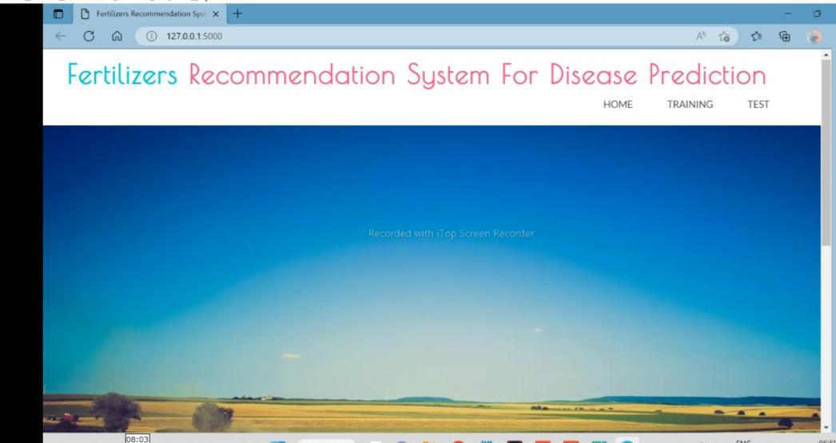

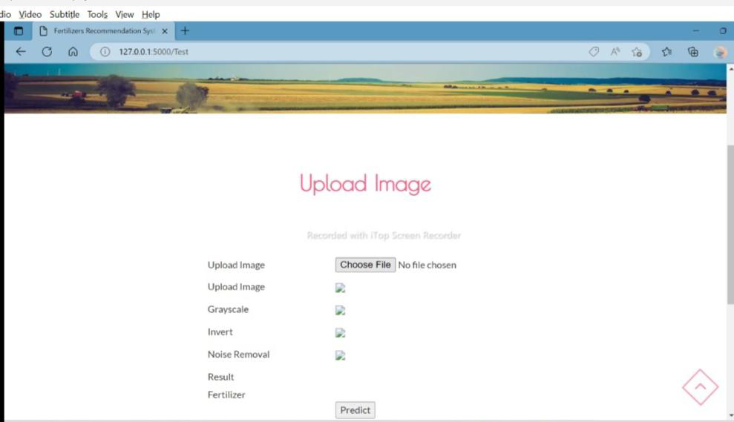

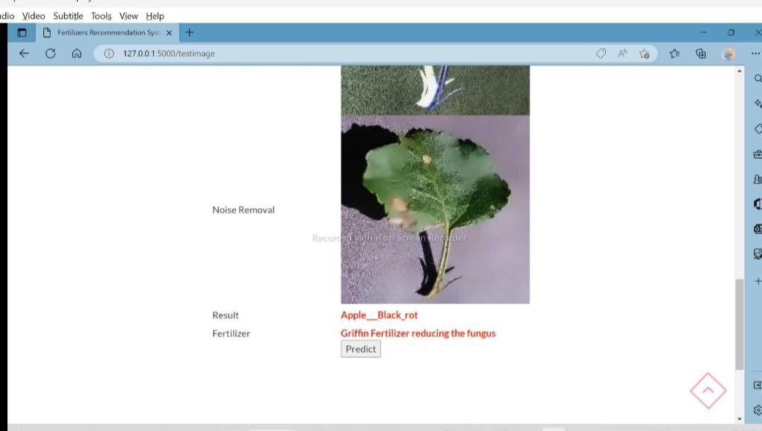

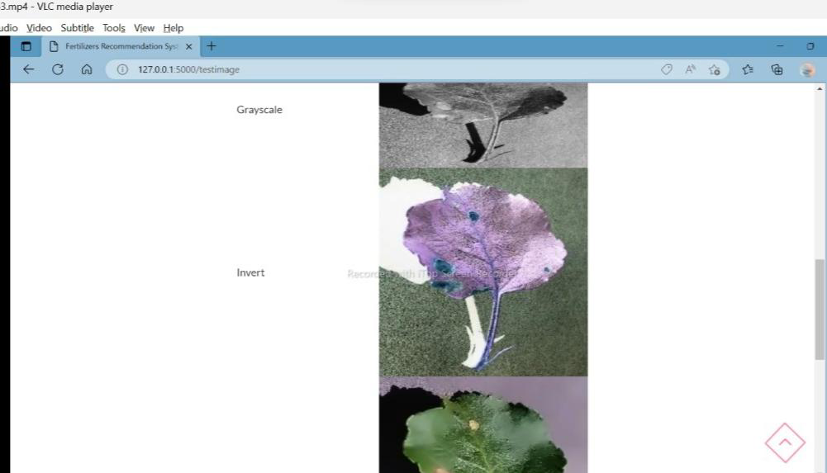

**Index.html**

from flask import Flask, render_template, flash, request, session,send_file

from flask import render_template, redirect, url_for, request

import warnings

import datetime

import cv2

app = Flask(__name__)

app.config['DEBUG']

app.config['SECRET_KEY'] = '7d441f27d441f27567d441f2b6176a'

@app.route("/")

def homepage():

return render_template('index.html')

@app.route("/Training")

def Training():

return render_template('Tranning.html')

@app.route("/Test")

def Test():

return render_template('Test.html')

@app.route("/train", methods=['GET', 'POST'])

def train():

if request.method == 'POST':

import model as model

return render_template('Tranning.html')

@app.route("/testimage", methods=['GET', 'POST'])

def testimage():

if request.method == 'POST':

file = request.files['fileupload']

file.save('static/Out/Test.jpg')

img = cv2.imread('static/Out/Test.jpg')

if img is None:

print('no data')

img1 = cv2.imread('static/Out/Test.jpg')

print(img.shape)

img = cv2.resize(img, ((int)(img.shape[1] / 5), (int)(img.shape[0] / 5)))

original = img.copy()

neworiginal = img.copy()

cv2.imshow('original', img1)

gray = cv2.cvtColor(img1, cv2.COLOR_BGR2GRAY)

img1S = cv2.resize(img1, (960, 540))

cv2.imshow('Original image', img1S)

grayS = cv2.resize(gray, (960, 540))

cv2.imshow('Gray image', grayS)

gry = 'static/Out/gry.jpg'

cv2.imwrite(gry, grayS)

from PIL import ImageOps,Image

im = Image.open(file)

im_invert = ImageOps.invert(im)

inv = 'static/Out/inv.jpg'

im_invert.save(inv, quality=95)

dst = cv2.fastNlMeansDenoisingColored(img1, None, 10, 10, 7, 21)

cv2.imshow("Nosie Removal", dst)

noi = 'static/Out/noi.jpg'

cv2.imwrite(noi, dst)

import warnings

warnings.filterwarnings('ignore')

import tensorflow as tf

classifierLoad = tf.keras.models.load_model('model.h5')

import numpy as np

from keras.preprocessing import image

test_image = image.load_img('static/Out/Test.jpg', target_size=(200, 200))

img1 = cv2.imread('static/Out/Test.jpg')

# test_image = image.img_to_array(test_image)

test_image = np.expand_dims(test_image, axis=0)

result = classifierLoad.predict(test_image)

out = ''

fer = ''

if result[0][0] == 1:

out = "Apple___Black_rot"

fer = 'Griffin Fertilizer reducing the fungus'

elif result[0][1] == 1:

out = "Apple___healthy"

elif result[0][2] == 1:

out = "Corn_(maize)___healthy"

elif result[0][3] == 1:

out = "Corn_(maize)___Northern_Leaf_Blight"

fer = 'Griffin Fertilizer reducing the fungus'

elif result[0][4] == 1:

out = "Peach___Bacterial_spot"

fer = 'Compounds available for use on peach and nectarine for bacterial spot include copper, oxytetracycline (Mycoshield and generic equivalents), and syllit+captan; however, repeated applications are typically necessary for even minimal disease control.'

elif result[0][5] == 1:

out = "Peach___healthy"

if result[0][6] == 1:

out = "Pepper_bell___Bacterial_spot"

fer = 'Griffin Fertilizer reducing the fungus'

elif result[0][7] == 1:

out = "Pepper_bell___healthy"

elif result[0][8] == 1:

out = "Potato___Early_blight"

fer = 'Griffin Fertilizer reducing the fungus'

elif result[0][9] == 1:

out = "Potato___healthy"

fer = 'Griffin Fertilizer reducing the fungus'

elif result[0][10] == 1:

out = "Potato___Late_blight"

fer = 'Griffin Fertilizer reducing the fungus'

elif result[0][11] == 1:

out = "Tomato___Bacterial_spot"

fer = 'Griffin Fertilizer reducing the fungus'

elif result[0][12] == 1:

out = "Tomato___Late_blight"

fer = 'Spraying fungicides is the most effective way to prevent late bligh'

elif result[0][13] == 1:

out = "Tomato___Leaf_Mold"

fer = 'Griffin Fertilizer reducing the fungus'

elif result[0][14] == 1:

out = "Tomato___Septoria_leaf_spot"

fer = 'Griffin Fertilizer reducing the fungus'

org = 'static/Out/Test.jpg'

gry ='static/Out/gry.jpg'

inv = 'static/Out/inv.jpg'

noi = 'static/Out/noi.jpg'

return render_template('Test.html',fer=fer,result=out,org=org,gry=gry,inv=inv,noi=noi)

if __name__ == '__main__':

app.run(debug=True, use_reloader=True)

**Base.html**

from keras.models import Sequential

from keras.layers import Convolution2D

from keras.layers import MaxPooling2D

from keras.layers import Flatten

from keras.layers import Dense

from keras.models import model_from_json

import matplotlib.pyplot as plt

import warnings

warnings.filterwarnings('ignore')

batch_size = 32

from tensorflow.keras.preprocessing.image import ImageDataGenerator

# All images will be rescaled by 1./255

train_datagen = ImageDataGenerator(rescale=1/255)

# Flow training images in batches of 128 using train_datagen generator

train_generator = train_datagen.flow_from_directory(

'DataSet', # This is the source directory for training images

target_size=(200, 200), # All images will be resized to 200 x 200

batch_size=batch_size,

# Specify the classes explicitly

classes = ['Apple___Black_rot','Apple___healthy','Corn_(maize)___healthy','Corn_(maize)___Northern_Leaf_Blight',

'Peach___Bacterial_spot','Peach___healthy','Pepper_bell___Bacterial_spot','Pepper_bell___healthy','Potato___Early_blight',

'Potato___healthy','Potato___Late_blight','Tomato___Bacterial_spot','Tomato___Late_blight',

'Tomato___Leaf_Mold','Tomato___Septoria_leaf_spot'],

# Since we use categorical_crossentropy loss, we need categorical labels

class_mode='categorical')

import tensorflow as tf

model = tf.keras.models.Sequential([

# Note the input shape is the desired size of the image 200x 200 with 3 bytes color

# The first convolution

tf.keras.layers.Conv2D(16, (3,3), activation='relu', input_shape=(200, 200, 3)),

tf.keras.layers.MaxPooling2D(2, 2),

# The second convolution

tf.keras.layers.Conv2D(32, (3,3), activation='relu'),

tf.keras.layers.MaxPooling2D(2,2),

# The third convolution

tf.keras.layers.Conv2D(64, (3,3), activation='relu'),

tf.keras.layers.MaxPooling2D(2,2),

# The fourth convolution

tf.keras.layers.Conv2D(64, (3,3), activation='relu'),

tf.keras.layers.MaxPooling2D(2,2),

# The fifth convolution

tf.keras.layers.Conv2D(64, (3,3), activation='relu'),

tf.keras.layers.MaxPooling2D(2,2),

# Flatten the results to feed into a dense layer

tf.keras.layers.Flatten(),

# 128 neuron in the fully-connected layer

tf.keras.layers.Dense(128, activation='relu'),

# 5 output neurons for 5 classes with the softmax activation

tf.keras.layers.Dense(15, activation='softmax')

])

model.summary()

from tensorflow.keras.optimizers import RMSprop

early = tf.keras.callbacks.EarlyStopping(monitor='val_loss',patience=5)

model.compile(loss='categorical_crossentropy',

optimizer=RMSprop(lr=0.001),

metrics=['accuracy'])

total_sample=train_generator.n

n_epochs = 10

history = model.fit_generator(

train_generator,

steps_per_epoch=int(total_sample/batch_size),

epochs=n_epochs,

verbose=1)

model.save('model.h5')

acc = history.history['accuracy']

loss = history.history['loss']

epochs = range(1, len(acc) + 1)

# Train and validation accuracy

plt.plot(epochs, acc, 'b', label=' accurarcy')

plt.title(' accurarcy')

plt.legend()

plt.figure()

# Train and validation loss

plt.plot(epochs, loss, 'b', label=' loss')

plt.title(' loss')

plt.legend()

plt.show()mport tensorflow as tf

import numpy as np

from tkinter import *

import os

from tkinter import filedialog

import cv2

import time

from matplotlib import pyplot as plt

from tkinter import messagebox

def endprogram():

print ("\nProgram terminated!")

sys.ex

def fulltraining():

import model as mm

def testing():

global testing_screen

testing_screen = Toplevel(main_screen)

testing_screen.title("Testing")

# login_screen.geometry("400x300")

testing_screen.geometry("600x450+650+150")

testing_screen.minsize(120, 1)

testing_screen.maxsize(1604, 881)

testing_screen.resizable(1, 1)

testing_screen.configure(bg='green')

# login_screen.title("New Toplevel")

Label(testing_screen, text='''Upload Image''', disabledforeground="#a3a3a3",

foreground="#000000", width="300", height="2", font=("Calibri", 16)).pack()

Label(testing_screen, text="").pack()

Label(testing_screen, text="").pack()

Label(testing_screen, text="").pack()

Button(testing_screen, text='''Upload Image''', font=(

'Verdana', 15), height="2", width="30", command=imgtest).pack()

global affect

def imgtest():

import_file_path = filedialog.askopenfilename()

image = cv2.imread(import_file_path)

print(import_file_path)

filename = 'Output/Out/Test.jpg'

cv2.imwrite(filename, image)

print("After saving image:")

#result()

#import_file_path = filedialog.askopenfilename()

print(import_file_path)

fnm = os.path.basename(import_file_path)

print(os.path.basename(import_file_path))

# file_sucess()

print("\n*********************\nImage : " + fnm + "\n*********************")

img = cv2.imread(import_file_path)

if img is None:

print('no data')

img1 = cv2.imread(import_file_path)

print(img.shape)

img = cv2.resize(img, ((int)(img.shape[1] / 5), (int)(img.shape[0] / 5)))

original = img.copy()

neworiginal = img.copy()

cv2.imshow('original', img1)

gray = cv2.cvtColor(img1, cv2.COLOR_BGR2GRAY)

img1S = cv2.resize(img1, (960, 540))

cv2.imshow('Original image', img1S)

grayS = cv2.resize(gray, (960, 540))

cv2.imshow('Gray image', grayS)

dst = cv2.fastNlMeansDenoisingColored(img1, None, 10, 10, 7, 21)

cv2.imshow("Nosie Removal", dst)

thresh = 127

im_bw = cv2.threshold(grayS, thresh, 255, cv2.THRESH_BINARY)[1]

#cv2.imshow("affect Removal", im_bw)

number_of_black_pix = np.sum(im_bw == 0)

#print(number_of_black_pix)

#if(number_of_black_pix<5000):

#affect =result()

def result():

import warnings

warnings.filterwarnings('ignore')

import tensorflow as tf

classifierLoad = tf.keras.models.load_model('firemodel.h5')

import numpy as np

from keras.preprocessing import image

test_image = image.load_img('Output/Out/Test.jpg', target_size=(200, 200))

img1 = cv2.imread('Output/Out/Test.jpg')

# test_image = image.img_to_array(test_image)

test_image = np.expand_dims(test_image, axis=0)

result = classifierLoad.predict(test_image)

out = ''

pre=''

if result[0][0] == 1:

out="Fire"

elif result[0][1] == 1:

out="Nofire"

messagebox.showinfo("Result", "Classfication Rssult : "+str(out)

def main_account_screen():

global main_screen

main_screen = Tk()

width = 600

height = 600

screen_width = main_screen.winfo_screenwidth()

screen_height = main_screen.winfo_screenheight()

x = (screen_width / 2) - (width / 2)

y = (screen_height / 2) - (height / 2)

main_screen.geometry("%dx%d+%d+%d" % (width, height, x, y))

main_screen.resizable(0, 0)

# main_screen.geometry("300x250")

main_screen.configure(bg='green')

main_screen.title("Forest Fire Detection ")

Label(text="Forest Fire Detection", width="300", height="5", bg='green', font=("Calibri", 16)).pack()

Button(text="Training", font=( 'Verdana', 15), height="2", width="30", bg='green',command=fulltraining,highlightcolor="black").pack(side=TOP)

Label(text="").pack()

Button(text="Testing", font=( 'Verdana', 15), height="2", width="30",bg='green', command=testing).pack(side=TOP)

Label(text="").pack()

main_screen.mainloop()

main_account_screen()

|  |  |
| --- | --- |

|  |  |
| --- | --- |